CHILD VOICE
ANNUAL REPORT 2023-2024
Mr.S.ANNADURAI
PROGRAMME DIRECTOR

CHILD VOICE
ANNUAL REPORT 2023-2024
Child Voice, is an Non Profit organization in Nilakottai Block, Dindigul District. It is committed to uplifting vulnerable children, particularly orphaned girls, Tribal children, destitute women and mill workers across 40 villages in Nilakottai block and Kodaikanal. Our multifaceted approach includes comprehensive education support to ensure access to quality learning opportunities, aiming to prevent school dropout and equip students with essential skills. Additionally, we provideskill training and entrepreneurship support, fostering economic independence and sustainable livelihoods. Through advocacy efforts, we raise awareness about child rights and constitutional rights, combating harmful practices like child marriage and labour. Targeted community outreach promotes a culture of respect for children's rights, creating protective environments free from exploitation and abuse. Child Voice's holistic approach, spanning education, skill development, and advocacy, aims to break the cycle of poverty and vulnerability.
VISION
A PROGRESSIVE SOCIETY THAT IS ACTIVELY INVOLVED IN PROMOTING AND SAFEGUARDING THE DEVELOPMENT OF CHILDREN. ​
MISSION
- Our Mission is ​- To empower underprivileged children and to ascertain their rights, particularly protection and participation.
- To establish sustainable communities that prioritize child development.
- To bring remarkable changes on the development of children through advocacy and networking.
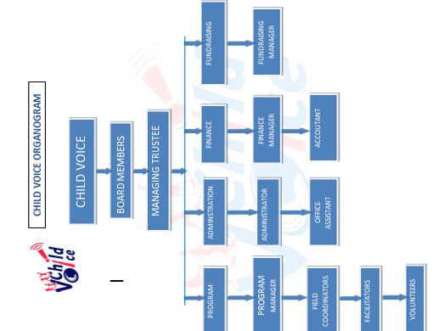

CURRENT PROJECTS
- EMPOWERING THE COMMUNITY TO PROTECT ADOLESCENT GIRLS AT RISK ( AZIM PREMJI FOUNDATION )
- HOPE CITIZEN PROGRAM FOR ADOLESCENT ( Hope Work Foundation )
- CONSTITUTIONAL RIGHTS EDUCATION

EMPOWERING THE COMMUNITY TO PROTECT ADOLESCENT GIRLS AT RISK project operates in 10 villages within Nilakottai Block, focusing on enhancing education and skills for adolescent students, while empowering vulnerable women and mill workers. Through Adolescent Action Groups for girls, Adolescent Boys Groups, Community Support Groups, and a dedicated Community Resource Centre. Enable to access social security schemes, education support, skill development training, entrepreneurship support, legal assistance, medical camps, career guidance, and capacity-building. Addressing issues such as child marriage, school dropout, child labour, and abuse.

Community Resource Centre
The Community Resource Centre (CRC) has successfully facilitated the formation of several community-focused groups, fostering engagement and support across various demographics in the ten villages it serves. Of 422 students( boys 196, girls-226) actively participating. the CRC and its associated groups play a vital role in promoting education, skill development and empowerment It providing the holistic support for the students.. The CRC has become a hub for collaboration, hosting monthly meetings for each group, including 4 for Adolescent Girls, 2 for Adolescent Boys.
Adolescents groups Formation( AAG/ABG)
Adolescent groups have been established across 10 villages, comprising 385 adolescent boys and girls, 198 adolescent girls and 187 adolescent boys were in the groups. with a focus on holistic development. The group educate the participants about the importance of education, foster awareness on personal health and hygiene, provide psychological support, and facilitate skill development. Additionally, it seeks to raise awareness about issues such as child marriage and child labour. Through various workshops, seminars, and interactive sessions, the groups conducting periodical meeting themselves and finding solutions to their challenges.
Community Support Group
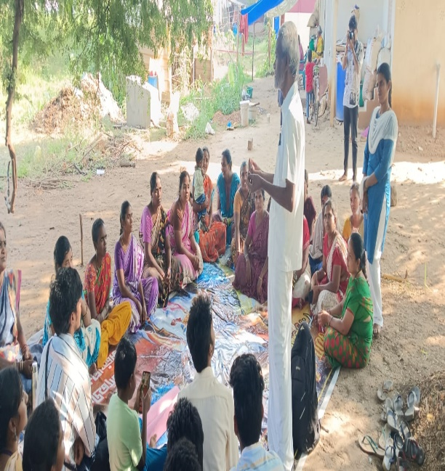
Ten community support groups have been established across villages, comprising 164 members including village 151 women, 13 men, leaders, and stakeholders. 10 CSG accounts opened with savings of Rs. 16800. These groups are dedicated to addressing community issues and safeguarding children. They actively combat issues such as child marriage, abuse, and child labour through awareness programs and community interventions.Due to the effort taken by CSG the above mentioned issues had been reduced in the villages.

Workers Support Group meeting
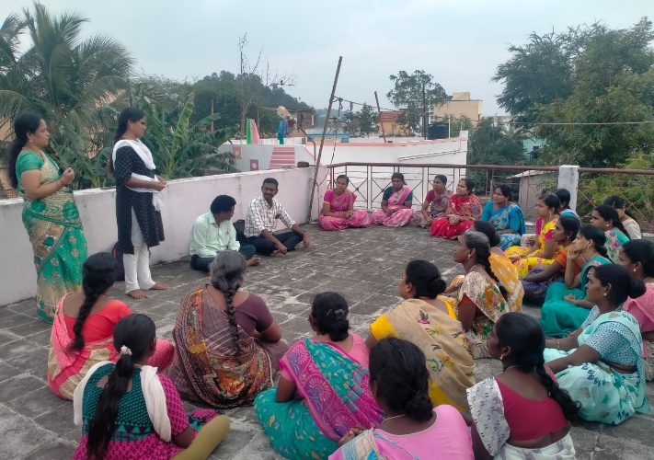
The Mill Workers Support Group Meetings served as vital platforms for mill workers across 10 villages to voice their concerns, exchange experiences, and seek solutions to their daily challenges. With a total of 199 members( 24 male,175 women), these gatherings facilitated discussions among workers. Nine meetings were held to establish and fortify these support groups. Programs were conducted in villages, including Mavuthanpatti with 80 participants, Malatheru with 78 workers and survivours, Velayudhapuram with 33 workers, old Silukkuvarpatti with 19 workers and Child Voice office with 60 participants. Workers gained knowledge about their rights and 4 applied for PF and 28 members for ESI.
Internal committee meeting
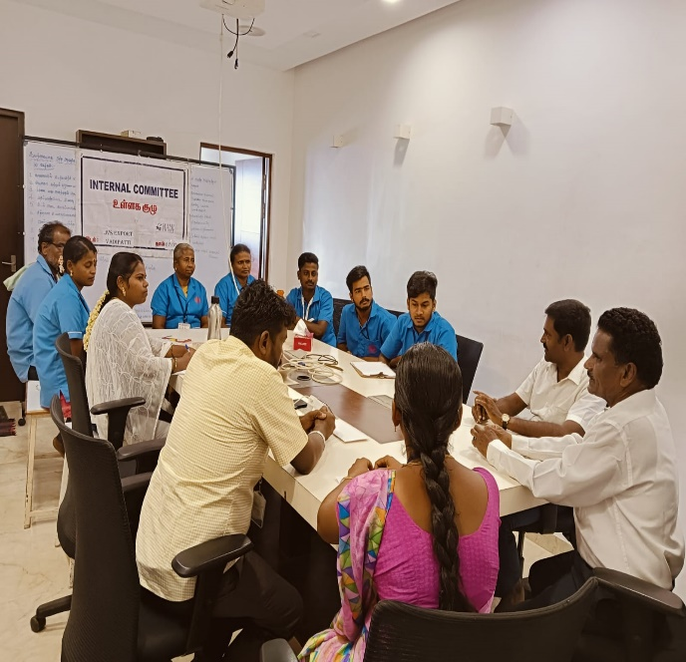
Seven Internal Committee Meetings were held in the garments with three meetings at Aarsha Garments Pallapatti , two at Sun Garments Pallapatti, one at Thavamani Garments, Sakkayanayakkanur and one at Quality Knit Wears Madurai. 74 female and 12 male workers participated in the meeting. The meetings ensured a safe, respectful, and compliant work environment. It leads to implementing safety protocols, hygiene, and sanitation measures in the workplace.

Career Guidance program
A career guidance program was conducted at the Nilakottai Union Office, with 65 students participating. The program aimed to provide valuable insights and resources to help students make informed decisions about their future careers.St Antony college proffessors Mrs Kavitha, Mr.Antone, Anugraha college professor Mr.Joseph, Mr.kasomayan from Annai academy given informatins on various career paths, educational opportunities, and skill development initiatives.The program emphasized the importance of goal-setting, self-assessment, and continuous learning in achieving success. Due to this program 21 went to Art and science college, 12 to Engineering, 7 to polytechnic, 5 to ITI and 4 to social studies.
Skill training and Entrepreneurship Development program
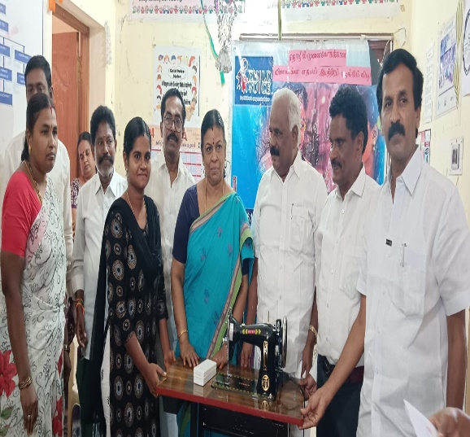
The Entrepreneur Development Program was conducted in the Child Voice office. Skill training on aari work and tailoring was given to 50 members. The MLA of Nilakottai Mrs.Thenmozhi and the Chairman of Nilakottai Mr. Yagappan were invited as the chief guest for the program. The primary objective was to foster entrepreneurship by providing training, material and guidance needed to establish and sustain their ventures. 32 vulnerable women from rural background engaging in diverse ventures.

Imitation Jewellery | 2 members
Aari work | 5 menbers
Tailoring machine | 16 members
Goat | 5 members
Petty shop | 1 member
Flower | 1 members
Fish | 1 members
Wet Grinder | 1 members

SMC meeting
As an active member of the School Management Committee (SMC), staff, and Community Support Group (CSG), we convened 16 meetings across 8 villages in Government schools, addressing critical issues such as school dropout, child labor, and child marriage. 13 CSG members and 10 facilitators are in SMC committee. Notably, in one village, parental reluctance to send girls beyond 10th grade due to the unavailability of 11th and 12th standards locally was highlighted. Clean toilet facility and napkin disposal arranged in Pallapatti Hr,sec school after discussed in SMC.
BCPC,VCPC meetings
The Block Level Child Protection Meeting was organized to discuss and address issues related to child protection within the Nilakottai block. Participated in 3 BCPC meetings and 9 VCPC meetings. Issues related to child labour, drug abuse were discussed. Officers went for an inspection to a garment near Nilakottai and found the child labourer and steps taken. In 18 wards facilitators were appointed as a members of ward-level child protection committees. The overall view of the meeting was to prevent child labour, child marriage and child abuse issues in the block.
Staff Meeting
The staff meetings were held to provide a platform for communication and updates among team members. Twelve monthly staff meetings were held and these sessions focused on reviewing ongoing projects, organizational goals, and addressing challenges to foster teamwork. Monthly and weekly review meetings were conducted to plan and evaluate work progress. Capacity building training, Training on ESI PF, Mental health and problem solving trainings were given in the meetings. Due to these training staff effectively implemented this knowledge in the community with confidence.

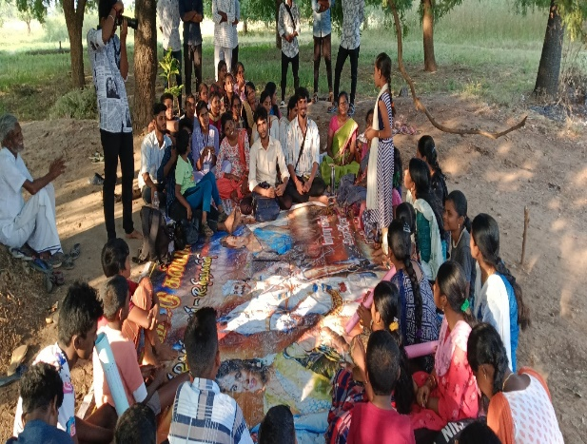
Gandhigram Deemed University Student Field Exposure
The objective of the student exposure program to the NGO was to provide students with firsthand experience and insights into the workings of a non-governmental organization, fostering social awareness, and encouraging community engagement. Through 2 visits 52 Students ( 33 Girls, 189 boys ) came for field exposure with their faculties Proffessor Mrs.Vanitha and the staff. Students learned about the role of NGO. The discussion covered areas such as education, healthcare, environmental conservation, and community development. They visited the Mavuthanpatti village for field exposure and had a fruitful interacted with AAG,ABG,CSG and WSG and gained knowledge about the community need and the programs implemented.
TOT training for self help group
Five Training of Trainers (TOT) meetings were organized to empower Self-Help Group (SHG) leaders, with a total attendance of 173 members. Led by Dr. Krishnamoorthi, a Consultant, and Father Philip Sudhakar. discussions revolved around the pivotal role of SHGs in community development and economic empowerment. They highlighted avenues for self-employment, entrepreneurship, skill development, and access to TAHDCO loans. Child Voice Director conducted training on budgeting, savings, investment, and maintaining accurate financial records for SHG sustainability. 14 bank accounts were opened, savings were conducted through this account and maintaining proper documents.
CSG Federation Formation & Strengthening Programme
The Community Support Group Federation Formation & Strengthening Programme aimed to empower local communities by enhancing the capabilities of support groups, fostering resilience, cooperation, and self-sustainability. Two programs were conducted in Child Voice, with 60 CSG leaders participating, resulting in the formation of a Federation among 10 Community Support Groups.Within this Federation, leaders were elected for key positions Mrs.Jeyamani as President, Mrs.Parijatha Kokila as Secretary and Mr.Rajendran as Truserer. They are facilitating and guiding the CSG.

TOT for workers support group
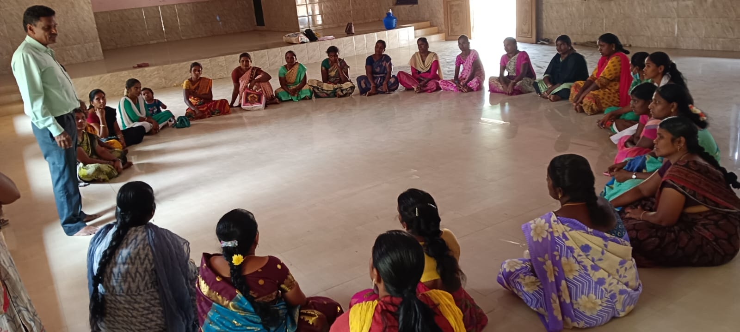
The Training of Trainers (TOT) for Mill Workers Support Group aimed to empower leaders within the mill worker community with essential skills for effective support. Two programs conducted in Mavuthanpatti and Ammayanayakkanur with 73 leaders ( 62 female,11 male) and specialized workshops addressed occupational health, collective bargaining, and mental well-being tailored to mill workers' challenges. Due to this training they gained knowledge of workers rights and negotiating for their needs with the companies.

TOT FOR AAG/ABG
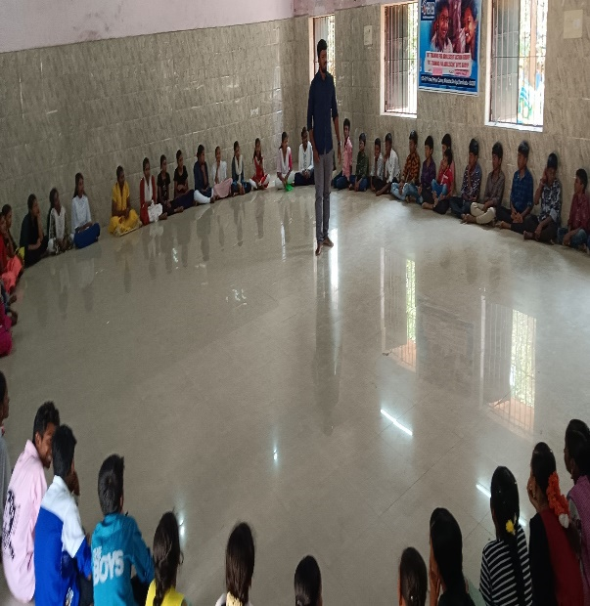
The Training of Trainers (TOT) for Adolescent Groups aimed to empower educators and facilitators in addressing the unique needs of adolescents. Two programs were conducted in Child Voice each for AAG and ABG. Two programs were held in Ammayanayakkanur community hall, conducted innovatively by expert resource person Mr. Anbu from Sakthi Vidiyal. The sessions focused on equipping trainers with skills to engage effectively with adolescents on topics like life skills, mental health, and personal development. A total of 60 adolescent boys group leaders and 60 adolescent girls group leaders from 10 villages were trained through these programs. They gained knowledge to lead the group and to make decision on any discussion.

Medical camp
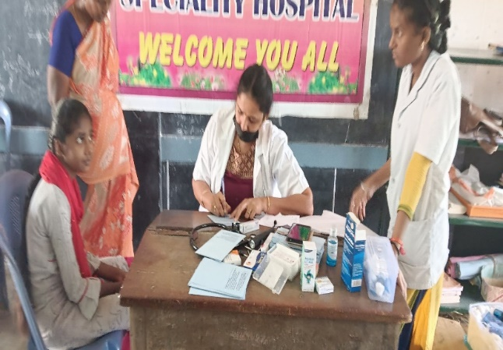
Child Voice, in collaboration with Lakshmana Hospital and Santhya Hospital, organized 7 impactful medical camps, 3 in Ammapatti, 2 in Mavuthanpatti, one in Nagayagoundan Patti and one in Malatheru. These camps catered to the healthcare needs of adolescents, mill workers, and the general public, benefiting 878 individuals ( Adolescent girls 270,adolescent boys 152, mill workers 206, survivor 108, general public 142). Specialized services included health checkups, consultations, treatment and informative sessions on preventive health measures. Issues such as RTI, irregular periods, hearing defects, ENT problems, and respiratory risks for mill workers were treated and referrals for further treatment as needed.
Trainer of Trainers Program for Community Support Group
The Training of Trainers (TOT) Program for Community Support Group Leaders aimed to bolster the leadership capabilities of key individuals within local support groups, fostering sustainable community development. Four programs held in Child Voice, with 153 participants ( 136 women,17 Men), the program empowered leaders with essential skills, knowledge, and tools for effective community mobilization. Enhanced leadership competencies were evident, resulting in improved decision-making and strategic planning. Critical issues like child marriage, child labour, school dropout, and drug abuse were addressed. CSG leaders enhance their knowledge and take ownership of their village and actively lead the group with healthy discussion and finding solutions within the group.
Mediation and Legal support
The provision of mediation and legal support to mill workers has been a crucial initiative in addressing the multifaceted challenges faced by the mill workers. Legal support was extended to ensure that workers' rights were protected and upheld. Advocate Bala had given legal advice to the 15 persons who came with 12 Provident funds and 3 ESI issues in their workplaces. Documents collected from them and steps taken.
Consulting with Local panchayat
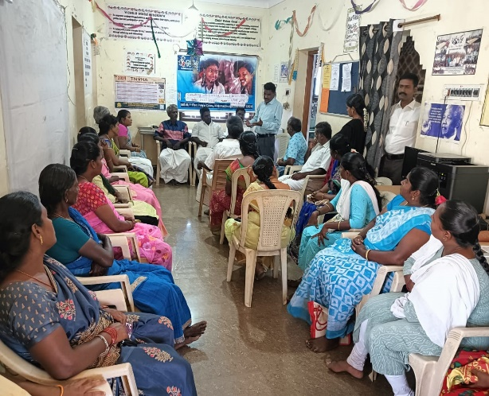
Consultations with local Panchayat leaders regarding child related issues in villages and migrant worker communities have proven to be instrumental in fostering community based solutions. 30 participants including Panchayat President of Pallapatti, ward members, counsellors panchayat clerks, community support group leaders,SHG leaders attended this program. Had a fruitful discussion to bring a Girls Higher Secondary school in Nilakottai. Decided to make a collaborative step to prevent drug usage of adolescent in the villages.
Education Support
The Education Support Program for vulnerable school students has been pivotal in aiding students facing socio-economic challenges. Through targeted interventions, it ensures equitable access to quality education by providing educational materials, financial aid for fees, and additional tutoring support as necessary. Twenty-three students, comprising 20 from schools and 3 from colleges, directly benefited from this initiative. Additionally, through the Hope Work project, another 86 students (40 from schools and 46 from colleges) received assistance. Regular monitoring and personalized attention further enhance academic performance and bolster confidence among these students, ultimately paving the way for their continued educational success and socio-economic upliftment.
Counselling Support
The Counseling Support Program for adolescent boys and girls plays a vital role in addressing their unique challenges and mental health needs. Acknowledging the transitional phase of adolescence, the program offers a safe and confidential space for young individuals to express their concerns, navigate emotional difficulties, and develop essential coping skills. Two programs were conducted in Child Voice and Pallapatti, benefiting a total of 127 adolescents ( Girls 72,boys 55 ). Professional counselors conduct one-to-one sessions, providing guidance on topics like self-esteem, peer relationships, and future aspirations.
Social Protection scheme linkages
Establishing linkages with social protection schemes has proven instrumental in providing support to 102 workers( 25 w employed at Aarsha Garments in Pallapatti, 47 workers in Intalia and 30 workers in Quality knit wear. By ensuring enrollment in health insurance programs, pension schemes, and other social protection measures, these workers now have access to crucial safety nets. Additionally, awareness sessions have been conducted to educate them about their entitlements and how to navigate the available support systems effectively.
For the community totally 5083 people likaged in various social protection schemes.
Social Protection Schemes | Total no Of Beneficiary
Bank account Opening | 506
Job card | 187
Voter ID | 237
Ration card | 30
Pan card | 405
Pension card | 32
Driving License | 9
Post Office A/C Opening | 47
BMJAY | 95
E-Sharam | 55
ESI card | 25
Ayushman bharat scheme | 352
Nalavariyum | 30
Income certificate | 186
Nativity certificate | 181
Selvamahal thittam | 175
Kisan credit card | 364
Insurance | 296
Linkage Aadhar card | 1468
Disability card | 47
Widow certificate | 101
Old age Pension | 164
Small/ Marginal Farmer certificate | 15
Compilation of welfare scheme for Sanitation worker | 32
THADCO | 17
PM Vishwakarma | 28
Total | 5083

Staff Capacity Building training( WSG)
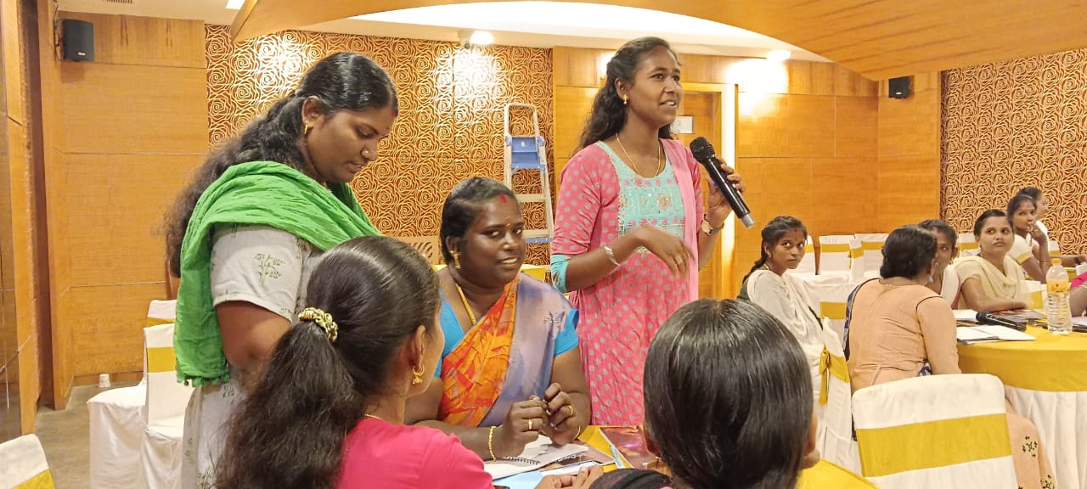
From February 11 to 13, 2024, a transformative three-day Staff Capacity Building Training on Worker's Support Group was conducted in Dindigul. The comprehensive program saw the participation of all staff members, including Program Managers, Field Coordinators (FCOs), and facilitators. Mr.Balamurugan led the sessions, imparting invaluable knowledge and skills crucial for supporting mill workers' groups effectively. The training encompassed various aspects, including organizational strategies, effective communication, and understanding the unique challenges faced by mill workers. This initiative reflects a commitment to continuous improvement and equipping staff with the necessary tools to make a positive impact on the lives of mill workers.

Hope- Citizen Program
Introduction
Child Voice and Hope Work Foundation persist in their mission to uplift the most vulnerable communities in Nilakottai and Dindigul. With a focus on destitute women's children, orphans, and semi-orphans, we provide educational support, skill-building programs, and community events. In the past year, our efforts intensified, emphasizing educational opportunities and holistic community development. Through essential resources and impactful events, we strive to create a sustainable, inclusive environment for all. Together, we work towards empowering marginalized members of society, fostering hope and resilience in our communities.

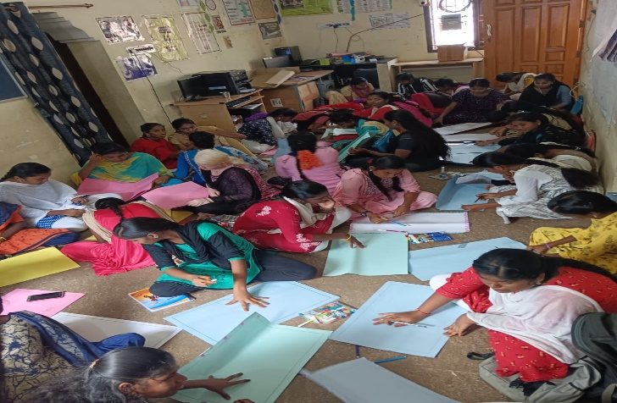
Activities
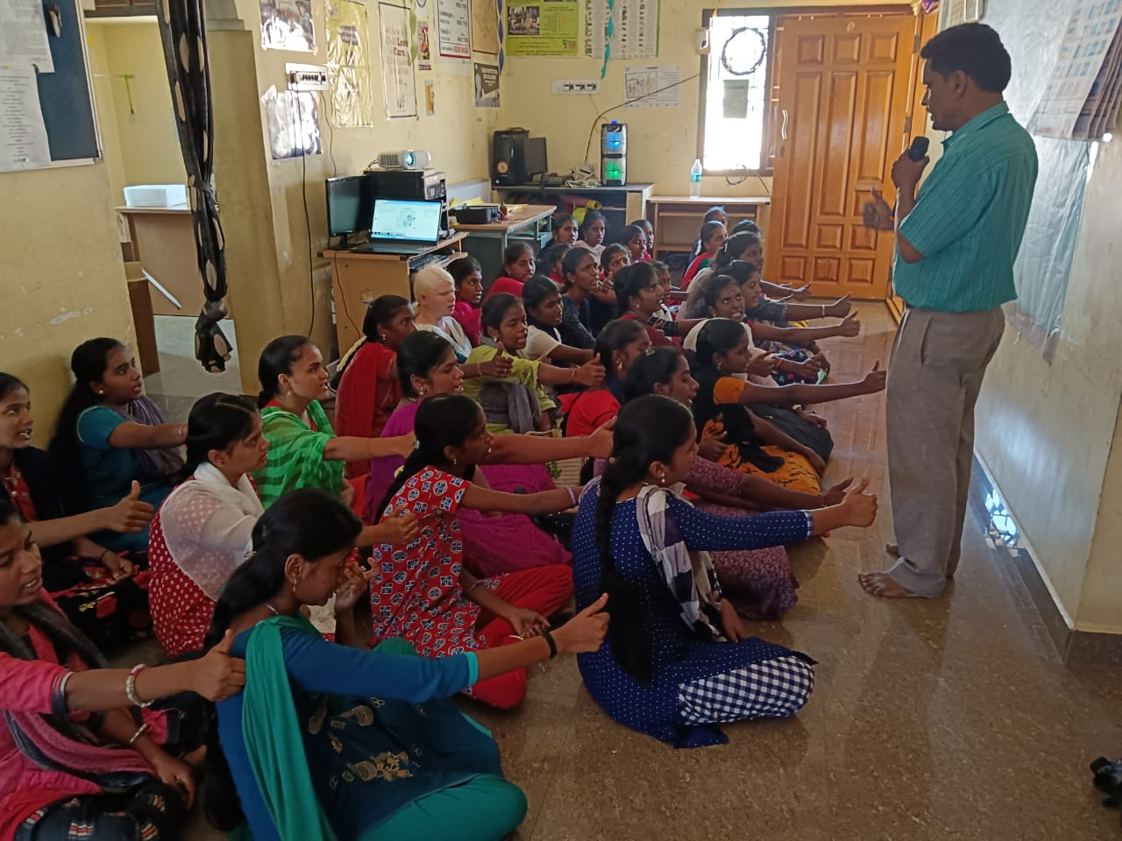
We support students in Nilakottai and Dindigul through various programs. Our educational assistance provides scholarships and study materials, removing financial barriers so students can attend school and college. Skill development initiatives focus on teaching English, computer skills, and personal growth, preparing students for future jobs and life challenges. Through community engagement events like celebrations and special gatherings, we promote unity and support among community members. We offer counseling and guidance to help students make informed decisions about their academic and professional paths. Health and hygiene awareness sessions, particularly for girls, educate on topics like menstrual hygiene and anemia, promoting overall well-being. Our empowerment initiatives aim to instill leadership qualities, encouraging students to become proactive contributors to community development. These efforts extend to various villages, including Ammapatti and Avayampatti, fostering holistic development and positive change in Nilakottai and Dindigul. We aspire to uplift and empower individuals, ensuring equal opportunities and creating a happier, more successful community for all.
Achievements:
57 students received scholarships, including 8 from the previous year. Among them, 1 student in 10th standard, 16 in 11th, 21 in 12th, and 19 are college students( Diploma Nursing-5, BA-5, B.Com-3, BSC-5,lab tech-1 ). Our outreach extended to 40 villages in the Nilakottai area. Significant academic improvement was observed among many students, underscoring the efficacy of our educational support initiatives.
Challenges Faced:
Limited resources posed a significant obstacle, constraining the scale of our programs and outreach efforts. Despite our dedication, the impact of our initiatives was hindered by financial constraints. Despite these hurdles, we remain committed to overcoming obstacles and continuing our mission to empower and uplift the communities we serve in Nilakottai and Dindigul.
Impact:
Over 48 weeks, Sunday skill development classes saw enthusiastic participation, highlighting talents in painting, elocution, and panel discussions. Students notably improved English reading and speaking skills, along with proficiency in computer operations. Despite family challenges causing two students to pause college studies, our commitment to holistic skill development continues steadfast. Through the HOPE Citizen Program, non-English readers are now reading English books and incorporating English into their speech. We persist in equipping students with essential competencies for personal and academic growth, ensuring a brighter future despite setbacks.

Constitutional Rights Education (CRE)
In Nilakottai block, Dindigul district, a Constitutional Rights Education Program is underway, organized by Child Voice across nine villages with 10 groups . The initiative involves seven facilitators dedicated to the project. A total of 140 students, comprising 70 boys and 70 girls from 6th to 9th standards, are participating. The distribution across standards is as follows: 6th standard has 22 boys and 23 girls, 7th standard has 24 boys and 25 girls, and 8th standard has 24 boys and 22 girls. Each group, led by the students themselves, conducts weekly meetings. Additionally, there are weekly Zoom meetings for staff members to enhance their teaching capabilities. The program's inauguration saw participation from village leaders at both the village and block levels, signifying community support and engagement. This holistic approach ensures a comprehensive and impactful educational experience for the students, empowering them with knowledge of their constitutional rights.
Activities
- Our School Enrollment Campaign successfully admitted 56 students to government schools, ensuring more children have access to quality education.
- At the Science Festival, 70 students showcased their scientific talents, promoting a culture of learning and exploration regardless of gender.
- World Menstrual Hygiene Day educated 35 women and 45 others on safe menstrual practices, empowering individuals with crucial health knowledge.
- The Self-Help Group Training session equipped 94 women and 7 men with leadership skills, fostering economic empowerment and community development.
- Drug Awareness Program engaged 54 boys, 67 girls, and teachers, raising awareness about the dangers of substance abuse and promoting healthy choices.
- By advocating against child marriage, our campaign involving 153 women and 13 men emphasized the importance of protecting children's rights and well-being.
- Through Constitutional Day Awareness and Human Rights Day, we educated 56 men, 67 women, and others about their rights and responsibilities, fostering a deeper understanding of citizenship and equality.
- World Tobacco Eradication Day and World Environment Day encouraged 25 men, 37 women, and others to take action for public health and environmental conservation.
- Campaign Against Child Labor, supported by 13 women, aims to raise awareness and advocate for policies to end child labor, safeguarding children's right to education and a safe childhood. Together, these efforts have made a tangible impact on our community, promoting education, health, and social justice for all.

Events & Celebrations
World Yoga Day
Ninety-three women and seven men joined in to celebrate World Yoga Day on June 12. The event focused on the benefits of yoga for both physical and mental health. Participants learned relaxation techniques and stress management, promoting a healthier lifestyle for everyone.
Kamarajar's Birthday
On July 15, 87 girls and 47 boys honored Kamarajar's birthday. Kamarajar was a leader known for his contributions to education and social reform. The event encouraged education and empowerment in the community, following Kamarajar's ideas.
National Girl Child Day
On January 25, 15 men and 17 women celebrated National Girl Child Day. The event focused on girls' rights and empowerment, advocating for gender equality, education, and protection. Such initiatives are vital for supporting girls' well-being and development.
International Women's Day
March 8 marked International Women's Day, with 57 women and 35 men participating. The event honored women's achievements and advocated for gender equality. By involving both women and men, the celebration highlighted the need for an inclusive and fair society for everyone.

Special Events
Bonded Labour Abolition Day
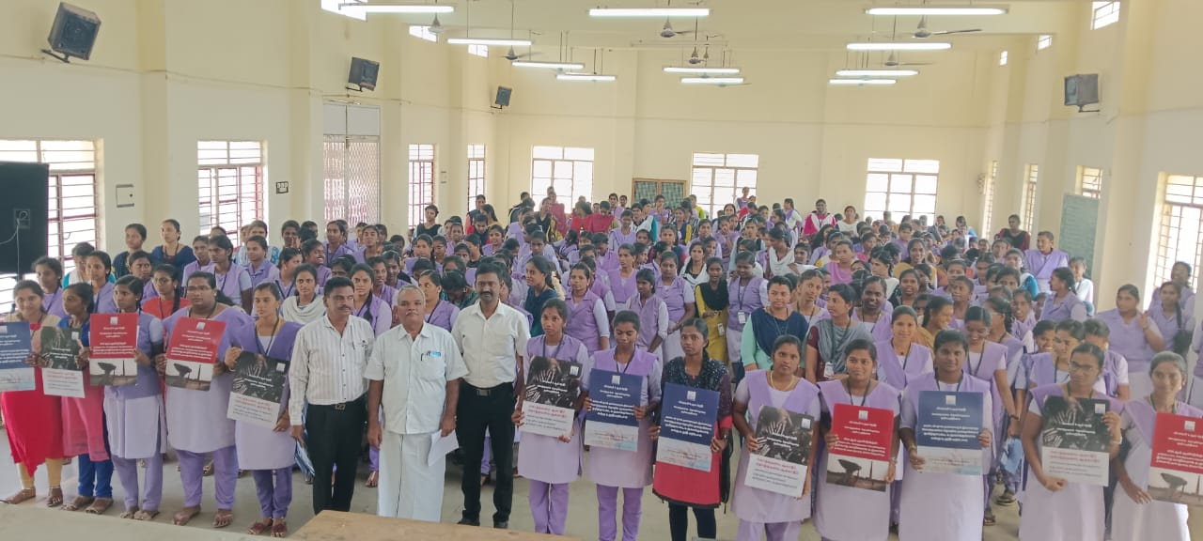
Bonded Labour Abolition Day awareness conducted on February 9, 2024, at Kulathupoatti Government Arts and Science College, drawing participation from 2600 students who took a solemn oath against bonded labour. Additionally, an awareness session was conducted at Sun Garments in Pallapatti, educating employees about the perils of bonded labour.

Road safety Initiative program
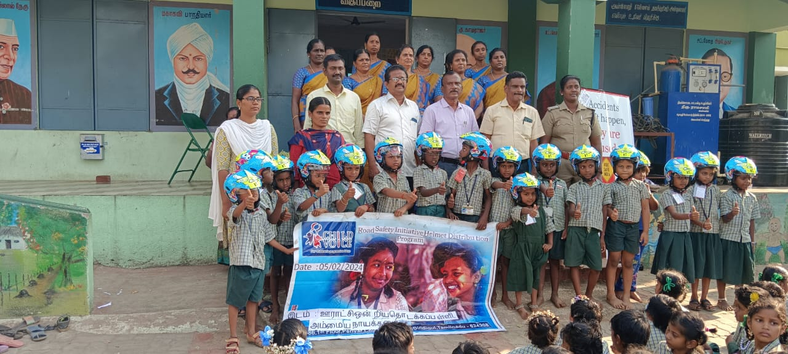
As part of Hero Company's Corporate Social Responsibility (CSR) initiatives, a meaningful road safety program conducted at Ammayanayakkanur Panchayat union primary School on 05.02.24. The event, graced by the presence of the Regional Transport Officer (RTO) and the Thasildhar as chief guests, saw the distribution of free helmets to 17 children. Childresns and parents gained knowledge about the importance of helmet wearing and road safety.
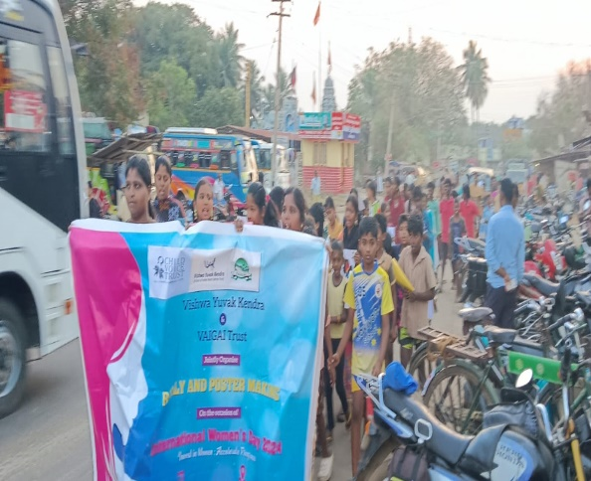
Womens day rally
On February 28, 2024, Pallapatti witnessed a spirited Women's Day rally, featuring 120 enthusiastic students. The rally commenced in Velayudhapuram and culminated at Pallapatti School. Members of the Community Support Group (CSG) and girls actively participated, The vibrant event not only celebrated the achievements of women but also emphasized the importance of gender equality and empowerment.

Out Come
- Community engaging in the project fosters a sense of ownership and responsibility. The community support group has opened bank accounts in 10 villages.
- Seven Child marriages stopped Velayudhapuram, Nagayagoundanpatti and Malatheru through AAG and Community support group.
- Nine School dropout students rejoined in schools after intervention and effort taken by the CSG.
- Legal support was provided for 15 mill workers in the Mediation and legal support programme.
- Entrepreneurship support to the most vulnerable women in the community. 32 mill workers, survivors and destitute women were supported for aari works, tailoring, goat, fish selling, imitation jewellery works.
- Workers support group formed in 10 villages with 180 mill workers and survivors and strengthened.
- Federations formed for Community support group and chosen leaders for the federation anf they actively participating in facilitating the groups..
- 45 Adolescent boys and 17 adolescent girls were were actively involved in sports activities like kabaddi and footbal and won District level competitions in Kabaddi.
- Community support groups participated in the 8 SMC meetings and insisted the childrens needs and the problems addressed and solved.
- Community people,mill workers and students were Linked with 5083 social protection schemes.
- Reduced child labour and children below 18 years working in the mills through active intervention.
- 140 students gained knowledge on constitutional rights education.
- 57 Orphan and semi orphan girl students received education scholarships and continued their studies.

Case study-1
In the village of Ammapatti, the impact of Child Voice's interventions on adolescents has been profound. Through targeted training sessions, these young individuals gained essential life skills, enabling them to become proactive contributors to their community. When a critical public drinking water pipeline broke, the trained adolescent boys noticed the issue and took decisive action. Despite initial setbacks, they collaborated effectively, presenting a detailed report to the village councillor. Impressed by their maturity and determination, the councillor promptly initiated steps to repair the pipeline. The swift response not only restored access to clean drinking water but also earned the boys admiration and respect from their peers and leaders alike. This incident underscores the transformative potential of empowering adolescents and fostering a sense of responsibility towards community welfare. By equipping youth with skills and confidence.The actions of the adolescent boys in Ammapatti serve as a powerful example of how empowered youth can lead positive change and inspire others to contribute to building sustainable communities.
Case study-2
Nithya ( Name Changed), a 19-year-old pursuing B.Sc Chemistry in Nilakottai's Arts College, faced familial challenges after losing her father, leaving her in a semi-orphaned situation. Despite her mother's suggestion to seek immediate employment after school, possibly due to financial constraints, Divya chose to pursue higher education. This decision posed a significant hurdle due to financial limitations. However, Divya's determination led her to apply for and secure a scholarship offered by the Hope Citizen Program, facilitating her college education.
Despite initial family opposition, Divya's perseverance paid off as she continues her studies supported by the scholarship. Her story exemplifies resilience and the pursuit of long-term opportunities for personal and professional growth. Divya's decision not only showcases her commitment to education but also highlights the transformative impact of financial assistance programs like the Hope Citizen Program. Despite facing adversity, Divya's journey reflects the power of determination and the ability to overcome challenges, paving the way for a brighter future and inspiring others to pursue their educational aspirations despite obstacles.

Case study-3
A success story of four students , Jaritha, Dharsh, Vel, and Surya who faced failure in their 10th-grade exams in Malayagoundan Patti village. The Community Resource Centre, led by a committed facilitator and staff, took proactive measures to address the challenge. Through collaboration with parents and discussions with the school headmaster, special exams tailored to the student's needs were arranged. With meticulous planning and support from all stakeholders, the exams provided a second chance for the students to prove themselves. Their resounding success marked a turning point in their academic journeys. Jaritha is now pursuing a diploma in nursing, while Dharsh, Surya, and Vel have embraced opportunities in polytechnic institutes. The success of these students has become a source of inspiration, fostering a positive academic environment in Malayagoundan Patti. This case study exemplifies how proactive community engagement, collaborative efforts, and tailored interventions can empower students to overcome academic challenges, showcasing the transformative impact of community-driven education initiatives.

PAPER NEWS

